

Bash Function Fundamentals: Building Blocks for Shell Script Automation

Function
- In Bash scripting, a function is a reusable block of code that performs a specific task.
- Functions allow you to organize and modularize your code, making it easier to read, maintain, and debug.
- Here’s a structured guide from basic to advanced, with practical examples for each level:

Basics of Functions in Bash
Objective: Introduce the syntax and purpose of functions in Bash.

Syntax:
function_name() {
# Commands
}

OR

function function_name {
# Commands
}
Example:
greet() {
echo "Hello, $1!"
}
# Calling the function
greet "Aamer" # Output: Hello, Aamer!

Explanation:

Functions are defined using function_name() { }. They can be called multiple times and allow parameters ($1, $2, etc.).

Function Parameters and Return Values
Objective: Teach students to pass arguments and capture return values from functions.




Passing Parameters:
add() {
result=$(( $1 + $2 )) echo $result
}
# Call the function with arguments sum=$(add 3 5)
echo "The sum is $sum" # Output: The sum is 8

Returning Values:

Since Bash functions can't return values directly like other languages, we use echo or global variables.

multiply() {
echo $(( $1 * $2 ))
}
product=$(multiply 4 7)
echo "Product is $product" # Output: Product is 28
Explanation:

Parameters are accessed using $1, $2, etc., and return values are handled by capturing echo
output.

Using Local Variables in Functions
Objective: Prevent variable conflicts by using local variables.

Syntax and Example:
calculate_square() { local num=$1
local result=$(( num * num )) echo $result
}
# Call the function square=$(calculate_square 6)
echo "Square is $square" # Output: Square is 36




Explanation:

local restricts the scope of a variable to the function, avoiding interference with variables outside the function.

Function Scope and Local Variables:

- Understand the concept of function scope and variable visibility.
- Use the local keyword to declare variables within a function.
- Demonstrate the difference between local and global variables.

Example:
# Function scope and local variables function print_message() {
local message="Hello from the function!"
echo "$message"
}
message="Hello from the main script!" print_message
echo "$message"

Advanced Function Reusability with Sourcing
Objective: Reuse functions across multiple scripts by sourcing.

Creating a Function Library (my_functions.sh):
# Define reusable functions greet() {
echo "Hello, $1!"
}
add() {
echo $(( $1 + $2 ))
}

Using the Function Library:
# Source the function library source my_functions.sh
# Call functions from the library

greet "Aamer" sum=$(add 10 15) echo "Sum is $sum"
Explanation:
# Output: Hello, Aamer! # Output: Sum is 25

By using source my_functions.sh, all functions from my_functions.sh are available in the current script, promoting modularity.

Recursive Functions
Objective: Implement recursive logic in Bash functions.

Example (Factorial):
factorial() {
if [ $1 -le 1 ]; then echo 1

else

fi
}

local temp=$(( $1 - 1 ))
local result=$(factorial $temp) echo $(( $1 * result ))




# Call the recursive function fact=$(factorial 5)
echo "Factorial is $fact" # Output: Factorial is 120
Explanation:

This factorial function calls itself, demonstrating recursion. Recursive functions require a base case to avoid infinite loops.

Using Functions with Arrays
Objective: Pass arrays to functions and work with complex data structures.

Example:
print_array() { local arr=("$@")
for element in "${arr[@]}"; do



echo "$element"
done
}
# Define an array and pass it to the function numbers=(1 2 3 4 5)
print_array "${numbers[@]}"

Explanation:
Arrays are passed using "$@" to handle each element properly, allowing functions to process lists of items.

Advanced Modularization and Function Namespaces
Objective: Use naming conventions to avoid conflicts in large scripts or when sourcing multiple function files.

Example:
math_add() {
echo $(( $1 + $2 ))
}
math_subtract() {
echo $(( $1 - $2 ))
}
# Usage sum=$(math_add 8 3)
diff=$(math_subtract 10 5)
echo "Sum: $sum, Difference: $diff"
Explanation:

By prefixing functions (e.g., math_), you create namespaces, reducing the chance of conflicts and making the script more readable.

Error Handling and Debugging in Functions
Objective: Implement error handling to make functions more robust.

Example:
divide() {

if [ $2 -eq 0 ]; then
echo "Error: Division by zero" return 1

else

fi
}

echo $(( $1 / $2 ))

result=$(divide 10 0) if [ $? -ne 0 ]; then
echo "An error occurred."

else

fi
Explanation:

echo "Result is $result"

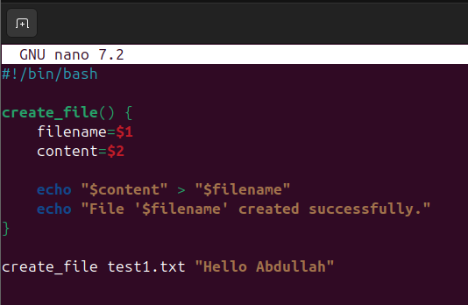

Functions can handle errors by checking conditions and using return to indicate failure, with
$? capturing the exit status.

Practice Questions
  - Write a function create_file that takes a filename and some content as arguments, creates the file (if it doesn't exist), and writes the content into the file.

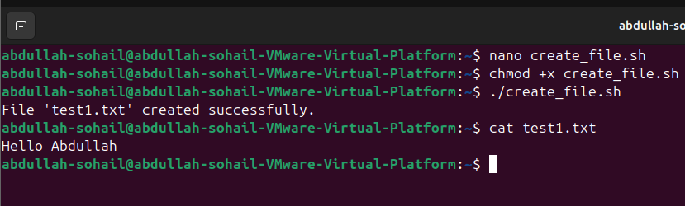
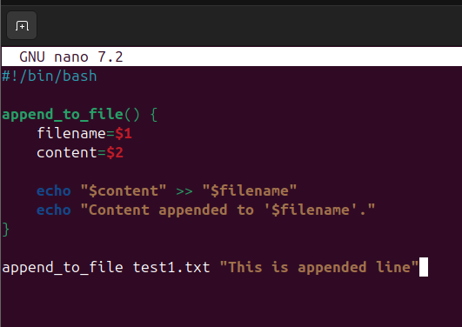
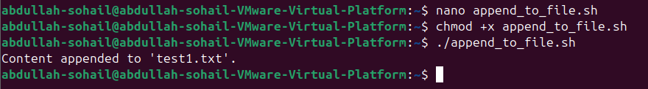
  - Write a function append_to_file that takes a filename and some content, appends the content to the file (creating it if it doesn't exist), and notifies the user.

  - Write a function read_file that reads the contents of a file and prints it to the terminal.

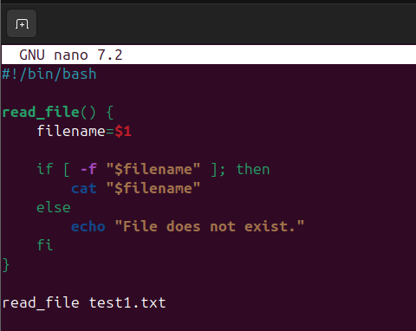
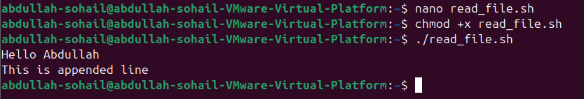
  - Write a function check_file_exists that checks if a file exists and returns an appropriate message.
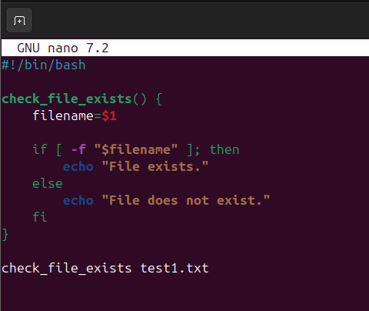

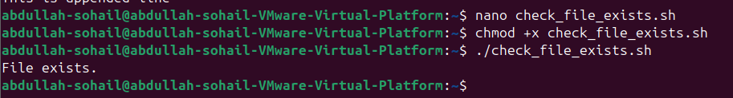
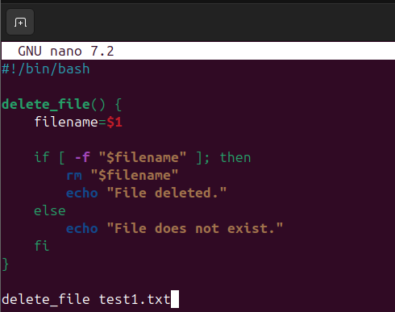
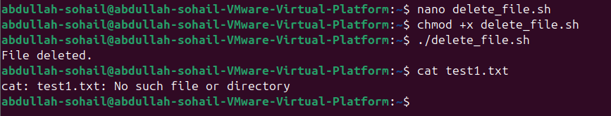
  - Write a function delete_file that deletes a specified file and notifies the user of the action.

  - Write a function backup_file that creates a backup of a file by copying it with a
.bak extension.

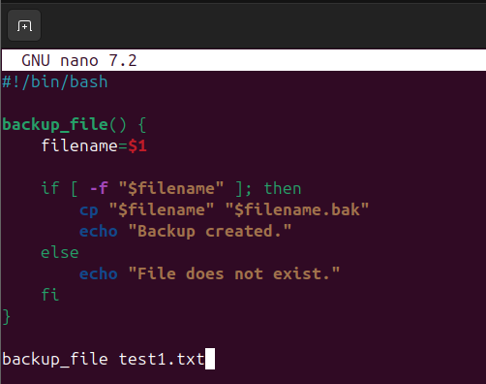
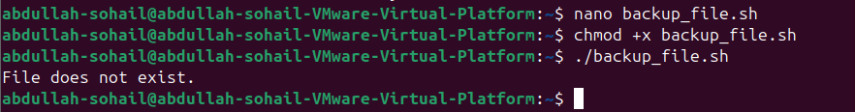

  - Write a function count_lines that counts and prints the number of lines in a given file.
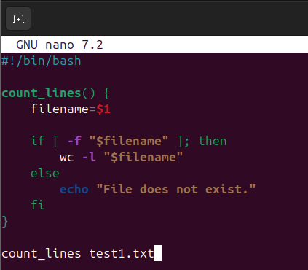

  - Write a function search_word that searches for a specific word in a file and prints all the lines containing that word.
